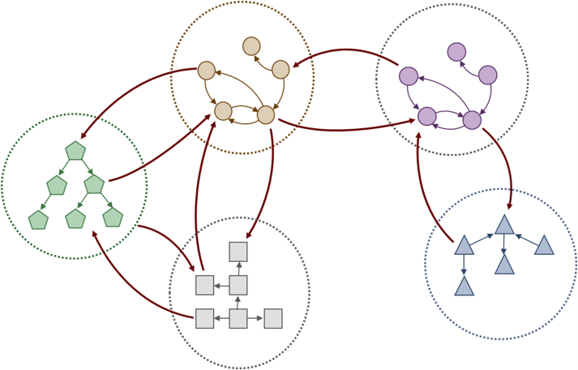

Eclipse Lyo  
An SDK to help you adopt OSLC specifications and build OSLC-compliant tools. http://eclipse.org/lyo/

Linked Lifecycle Data:   
The Next Generation of Collaboration

open-services.net

How it’s built…

ALM, ISM, and PLM Specifications based on a core specification

**The OSLC Core** specifies the primary integration techniques for integrating lifecycle tools, such as communication protocols and basic data representation

**The OSLC domain** *workgroups* specify additional vocabulary specific to their lifecycle domain, but do not add new protocols

Learn more and see how you or your company can benefit from using OSLC

Participate in the community as Lifecycle Domain Expert, Software or Systems Engineer

Open Services for Lifecycle Collaboration (OSLC)  
Lifecycle integration inspired by the web

Tool integration and interoperability based on open and standard internet technologies

OSLC key features support:

* Sharing of data and information
* Traceability of all artifacts
* Visibility into all aspects of the implementation process
* Control through policies and processes

Lifecycle Tool  
Requirements  
Management

Lifecycle Tool  
Quality Management

Lifecycle Tool  
Change Management

Service Management  
Deployment

Service Management  
Help Desk