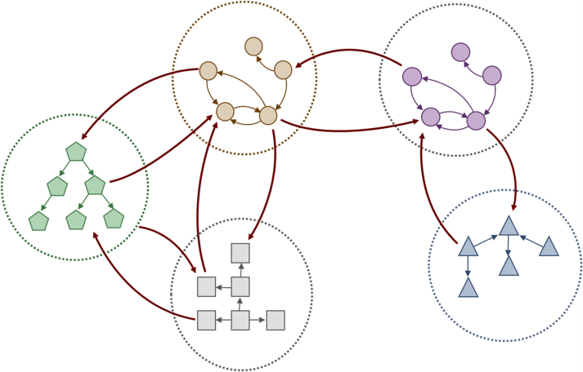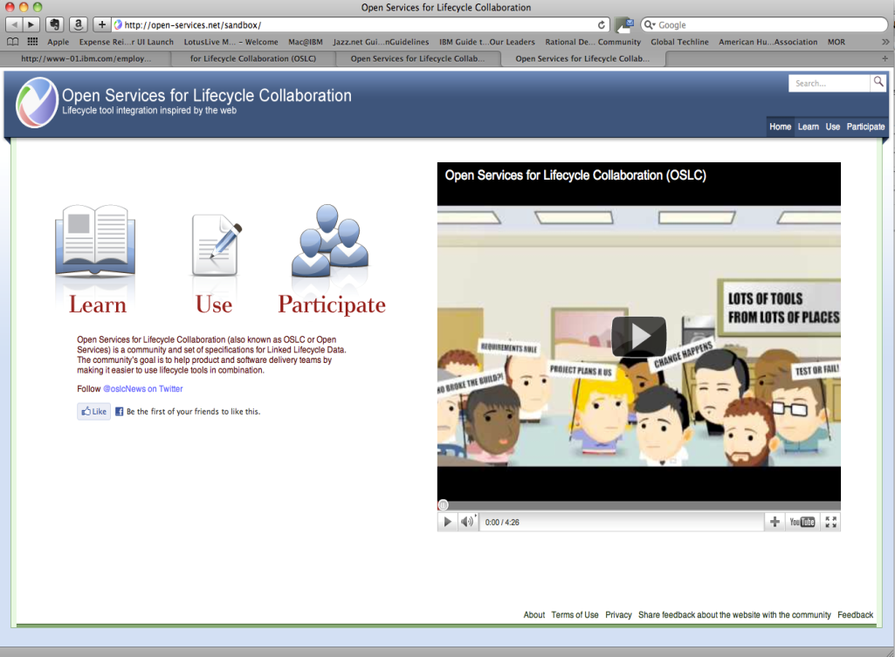

Open Services for Lifecycle Collaboration (OSLC)  
Lifecycle integration inspired by the web

How it’s built…

Different ALM, ISM, and PLM Specifications based on a core specification

The OSLC Core specifies the primary integration techniques for integrating lifecycle tools, such as communication protocols and basic data representation

The OSLC domain workgroups specify additional vocabulary specific to their lifecycle domain, but do not add new protocols

Learn more and see how you or your company can benefit from using OSLC

Participate and contribute to OSLC regardless of whether you are a Lifecycle Domain Expert, want to become one, a Software Developer, or Systems Engineer

Tool Integration and Interoperability based on open and standard Internet Technologies

OSLC key features support:

* Sharing of data and information
* Traceability of all artifacts
* Visibility into all aspects of the implementation process
* Control through policies and processes

Lifecycle Tool  
Requirements  
Management

Lifecycle Tool  
Quality Management

Lifecycle Tool  
Change Management

Service Management  
Deployment

Service Management  
Help Desk

The Next Generation of Collaboration Linked Lifecycle Data…

open-services.net