HSUV example in
Rational Engineering Lifecycle Manager 1.x

Screenshots of setting up product tree
Create products using names without “version” so that the pd:Item and pd:Part resources get the desired names for this example:

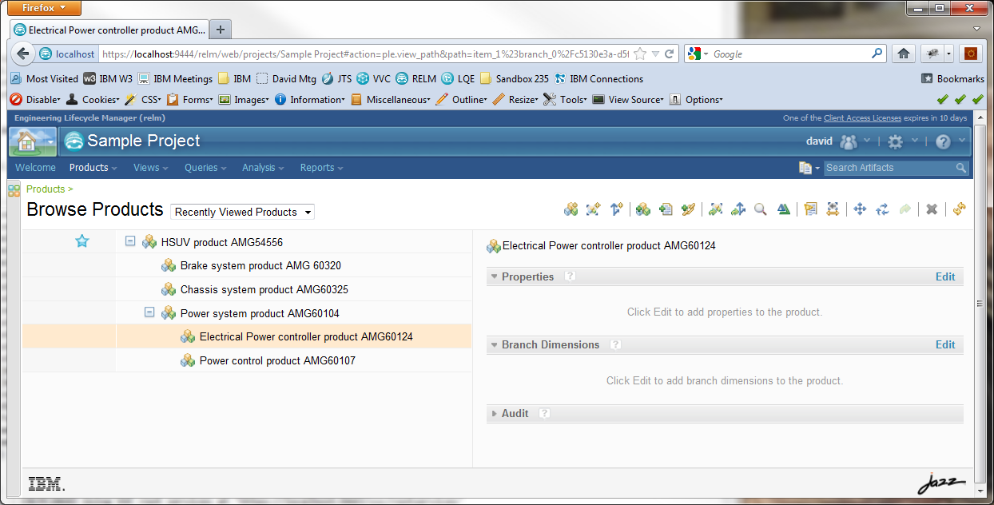

Rename all the nodes to add “version 1” to name:

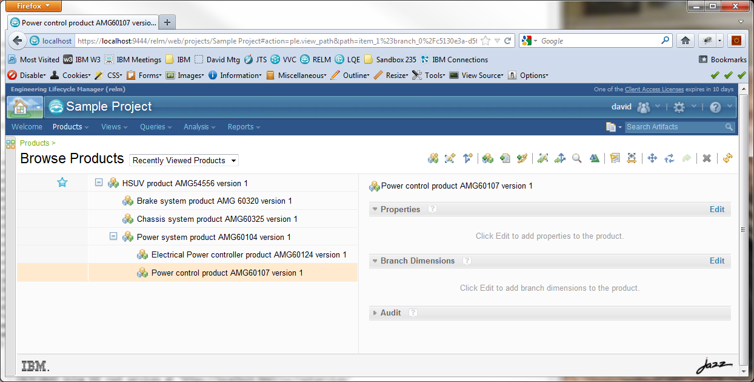

Create snapshot “snapshot 1”:

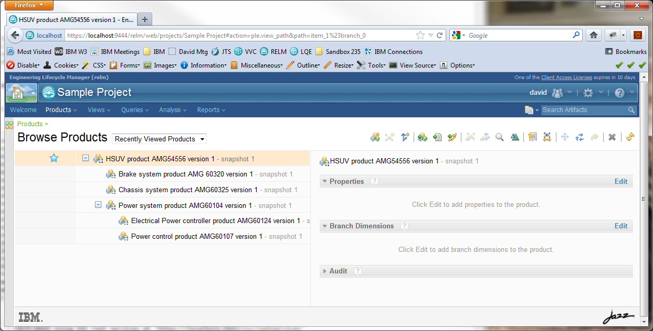

Change “version 1” in name to “version 2” for AMG54556, AMG60104, AMG60107:

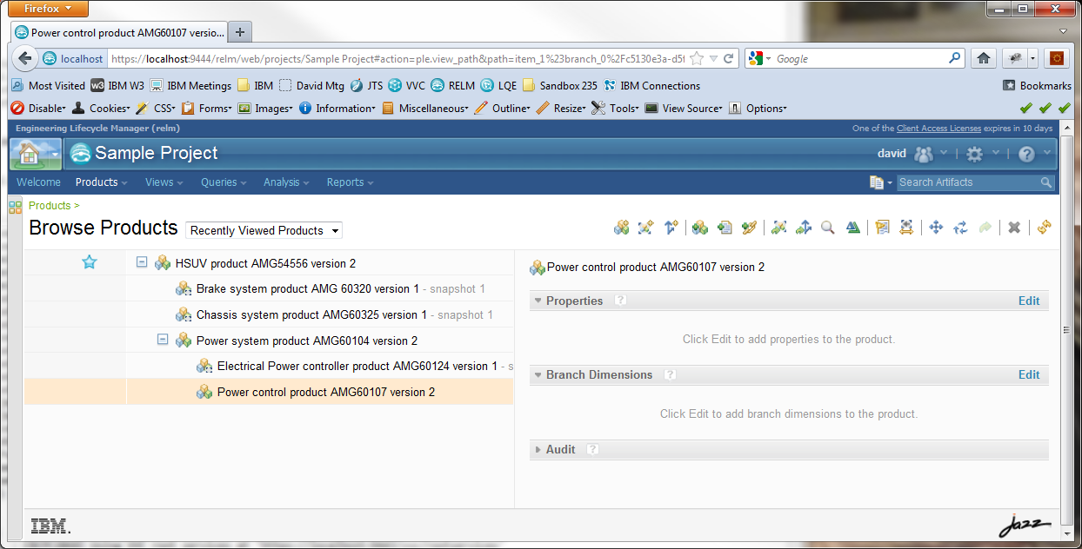

Create snapshot of AMG60104 named “snapshot 2”:

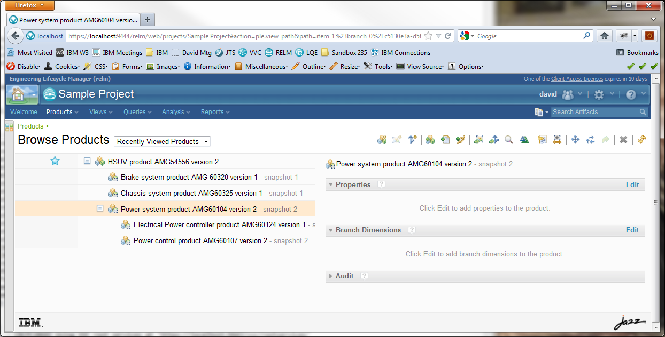

Change “version 2” to “version 3” in name for AMG60104, AMG60107:

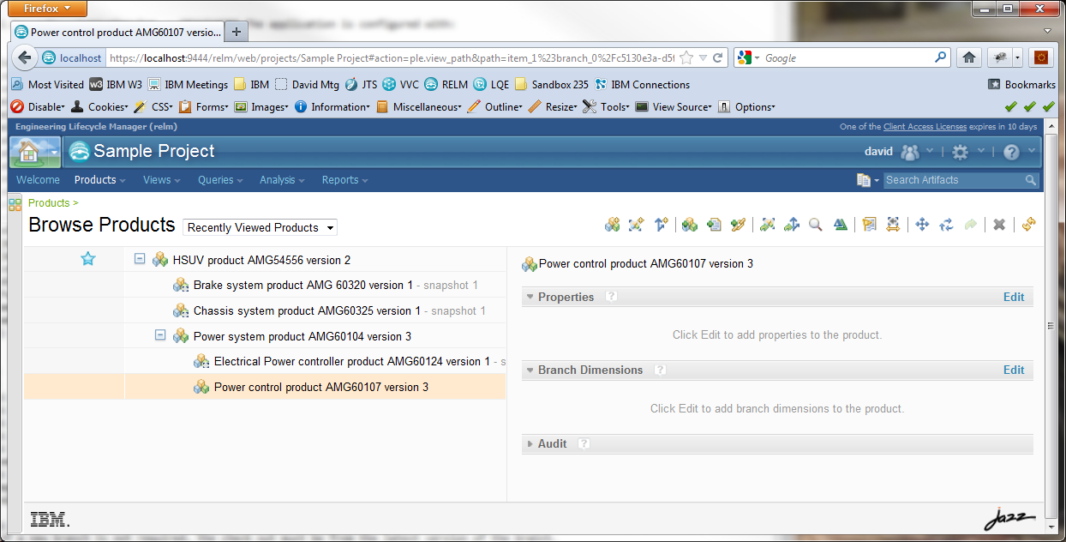

Create snapshot of AMG60104 named “snapshot 3”:

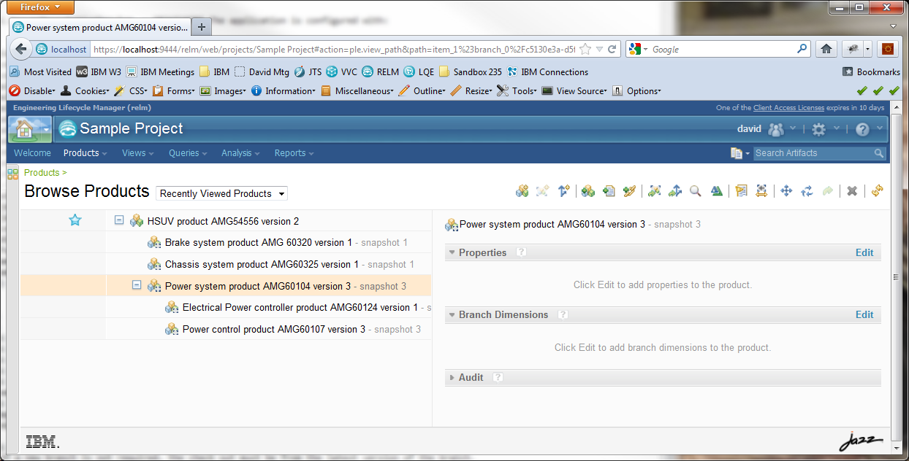

Change “version 3” to “version 4” in name of AMG60104:

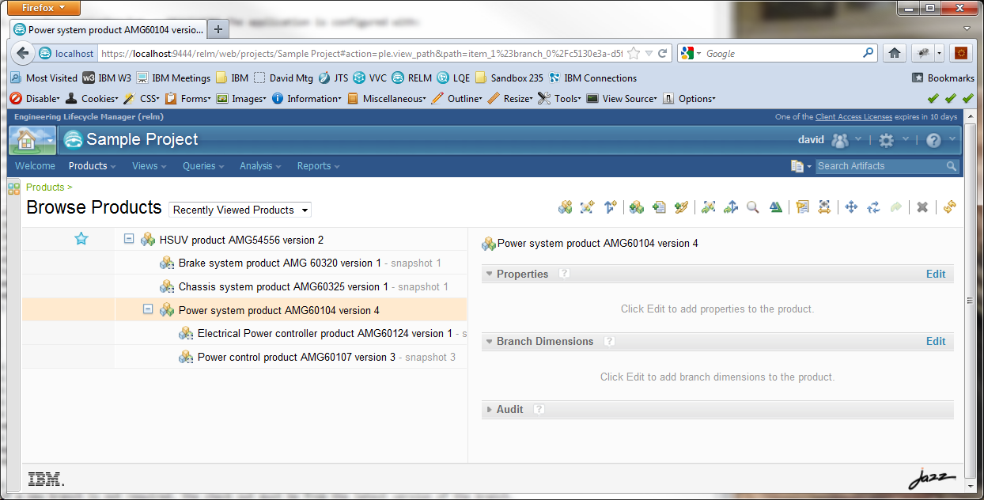

Product trees expressed as resources
In the resource trees shown on the following pages, the following conventions are used:
- Each resource is shown as a shaded box. The first line is the graph resource URI. This is a clickable link that, when followed, navigates to the TRS-exposed RDF for that resource. The second line shows the dcterms:title value of the resource.
- Item versions are shown with a tan background.
- Views are shown with a light blue background.
- Parts are shown with a light green background.
https://localhost:9444/relm/productdef/resource/itemVersion_1
HSUV product AMG54556 version 1
https://localhost:9444/relm/productdef/resource/view_1
Composition
https://localhost:9444/relm/productdef/resource/part_1
Power system product AMG60104
https://localhost:9444/relm/productdef/resource/part_2
Brake system product AMG 60320
https://localhost:9444/relm/productdef/resource/part_3
Chassis system product AMG60325
https://localhost:9444/relm/productdef/resource/itemVersion_2
Power system product AMG60104 version 1
https://localhost:9444/relm/productdef/resource/itemVersion_3
Brake system product AMG 60320 version 1
https://localhost:9444/relm/productdef/resource/itemVersion_4
Chassis system product AMG60325 version 1
https://localhost:9444/relm/productdef/resource/view_2
Composition
https://localhost:9444/relm/productdef/resource/view_3
Composition
https://localhost:9444/relm/productdef/resource/part_4
Power control product AMG60107
https://localhost:9444/relm/productdef/resource/part_5
Electrical Power controller product AMG60124
https://localhost:9444/relm/productdef/resource/itemVersion_5
Power control product AMG60107 version 1
https://localhost:9444/relm/productdef/resource/view_5
Composition
https://localhost:9444/relm/productdef/resource/itemVersion_6
Electrical Power controller product AMG60124 version 1
https://localhost:9444/relm/productdef/resource/view_6
Composition
https://localhost:9444/relm/productdef/resource/view_4
Composition
Snapshot “snapshot 1”

https://localhost:9444/relm/productdef/resource/itemVersion_7
HSUV product AMG54556 version 2

https://localhost:9444/relm/productdef/resource/view_7
Composition
https://localhost:9444/relm/productdef/resource/part_6

Power system product AMG60104
https://localhost:9444/relm/productdef/resource/part_7
Brake system product AMG 60320
https://localhost:9444/relm/productdef/resource/part_8
Chassis system product AMG60325
https://localhost:9444/relm/productdef/resource/itemVersion_12
Power system product AMG60104 version 4
https://localhost:9444/relm/productdef/resource/itemVersion_3
Brake system product AMG 60320 version 1
https://localhost:9444/relm/productdef/resource/itemVersion_4
Chassis system product AMG60325 version 1
https://localhost:9444/relm/productdef/resource/view_12
Composition
https://localhost:9444/relm/productdef/resource/view_3
Composition
https://localhost:9444/relm/productdef/resource/part_13
Power control product AMG60107
https://localhost:9444/relm/productdef/resource/part_14
Electrical Power controller product AMG60124
https://localhost:9444/relm/productdef/resource/itemVersion_11
Power control product AMG60107 version 3
https://localhost:9444/relm/productdef/resource/view_11
Composition
https://localhost:9444/relm/productdef/resource/itemVersion_6
Electrical Power controller product AMG60124 version 1
https://localhost:9444/relm/productdef/resource/view_6
Composition
https://localhost:9444/relm/productdef/resource/view_4
Composition
Latest Version

TRS exposed RDF

https://localhost:9444/relm/productdef/resource/itemVersion_1
@prefix vvc: <http://jazz.net/ns/vvc#> .
@prefix rdf: <http://www.w3.org/1999/02/22-rdf-syntax-ns#> .
@prefix pd: <http://jazz.net/ns/pd#> .
@prefix pd_ext: <http://jazz.net/ns/pd/extensions#> .
@prefix dcterms: <http://purl.org/dc/terms/> .
@prefix acp: <http://jazz.net/ns/acp#> .

<https://localhost:9444/relm/productdef/resource/item_1>
a pd:Item ;
pd_ext:creator <https://localhost:9443/jts/users/david> ;
pd_ext:immutable "true"^^<http://www.w3.org/2001/XMLSchema#boolean> ;
pd_ext:snapshot <https://localhost:9444/relm/productdef/resource/snapshot_1> ;
dcterms:created "2012-12-13T15:53:16.876Z"^^<http://www.w3.org/2001/XMLSchema#dateTime> ;
dcterms:creator <https://localhost:9443/jts/users/david> ;
dcterms:identifier "itemVersion_1" ;
dcterms:title "HSUV product AMG54556 version 1" .

<https://localhost:9444/relm/productdef/resource/itemVersion_1>
a pd:ItemVersion ;
acp:accessControl <https://localhost:9444/relm/productdef/trsacp> ;
dcterms:isVersionOf <https://localhost:9444/relm/productdef/resource/item_1> .

https://localhost:9444/relm/productdef/resource/itemVersion_2
@prefix vvc: <http://jazz.net/ns/vvc#> .
@prefix rdf: <http://www.w3.org/1999/02/22-rdf-syntax-ns#> .
@prefix pd: <http://jazz.net/ns/pd#> .
@prefix pd_ext: <http://jazz.net/ns/pd/extensions#> .
@prefix dcterms: <http://purl.org/dc/terms/> .
@prefix acp: <http://jazz.net/ns/acp#> .

<https://localhost:9444/relm/productdef/resource/item_2>
a pd:Item ;
pd_ext:creator <https://localhost:9443/jts/users/david> ;
pd_ext:immutable "true"^^<http://www.w3.org/2001/XMLSchema#boolean> ;
pd_ext:snapshot <https://localhost:9444/relm/productdef/resource/snapshot_1> ;
dcterms:created "2012-12-13T15:54:00.467Z"^^<http://www.w3.org/2001/XMLSchema#dateTime> ;
dcterms:creator <https://localhost:9443/jts/users/david> ;
dcterms:identifier "itemVersion_2" ;
dcterms:title "Power system product AMG60104 version 1" .

<https://localhost:9444/relm/productdef/resource/itemVersion_2>
a pd:ItemVersion ;
acp:accessControl <https://localhost:9444/relm/productdef/trsacp> ;
dcterms:isVersionOf <https://localhost:9444/relm/productdef/resource/item_2> .

https://localhost:9444/relm/productdef/resource/itemVersion_3
@prefix vvc: <http://jazz.net/ns/vvc#> .
@prefix rdf: <http://www.w3.org/1999/02/22-rdf-syntax-ns#> .
@prefix pd: <http://jazz.net/ns/pd#> .
@prefix pd_ext: <http://jazz.net/ns/pd/extensions#> .
@prefix dcterms: <http://purl.org/dc/terms/> .
@prefix acp: <http://jazz.net/ns/acp#> .

<https://localhost:9444/relm/productdef/resource/item_3>
a pd:Item ;
pd_ext:creator <https://localhost:9443/jts/users/david> ;
pd_ext:immutable "true"^^<http://www.w3.org/2001/XMLSchema#boolean> ;
pd_ext:snapshot <https://localhost:9444/relm/productdef/resource/snapshot_1> ;
dcterms:created "2012-12-13T15:54:15.469Z"^^<http://www.w3.org/2001/XMLSchema#dateTime> ;
dcterms:creator <https://localhost:9443/jts/users/david> ;
dcterms:identifier "itemVersion_3" ;
dcterms:title "Brake system product AMG 60320 version 1" .

<https://localhost:9444/relm/productdef/resource/itemVersion_3>
a pd:ItemVersion ;
acp:accessControl <https://localhost:9444/relm/productdef/trsacp> ;
dcterms:isVersionOf <https://localhost:9444/relm/productdef/resource/item_3> .

https://localhost:9444/relm/productdef/resource/itemVersion_4
@prefix vvc: <http://jazz.net/ns/vvc#> .
@prefix rdf: <http://www.w3.org/1999/02/22-rdf-syntax-ns#> .
@prefix pd: <http://jazz.net/ns/pd#> .
@prefix pd_ext: <http://jazz.net/ns/pd/extensions#> .
@prefix dcterms: <http://purl.org/dc/terms/> .
@prefix acp: <http://jazz.net/ns/acp#> .

<https://localhost:9444/relm/productdef/resource/item_4>
a pd:Item ;
pd_ext:creator <https://localhost:9443/jts/users/david> ;
pd_ext:immutable "true"^^<http://www.w3.org/2001/XMLSchema#boolean> ;
pd_ext:snapshot <https://localhost:9444/relm/productdef/resource/snapshot_1> ;
dcterms:created "2012-12-13T15:54:30.188Z"^^<http://www.w3.org/2001/XMLSchema#dateTime> ;
dcterms:creator <https://localhost:9443/jts/users/david> ;
dcterms:identifier "itemVersion_4" ;
dcterms:title "Chassis system product AMG60325 version 1" .

<https://localhost:9444/relm/productdef/resource/itemVersion_4>
a pd:ItemVersion ;
acp:accessControl <https://localhost:9444/relm/productdef/trsacp> ;
dcterms:isVersionOf <https://localhost:9444/relm/productdef/resource/item_4> .

https://localhost:9444/relm/productdef/resource/itemVersion_5
@prefix vvc: <http://jazz.net/ns/vvc#> .
@prefix rdf: <http://www.w3.org/1999/02/22-rdf-syntax-ns#> .
@prefix pd: <http://jazz.net/ns/pd#> .
@prefix pd_ext: <http://jazz.net/ns/pd/extensions#> .
@prefix dcterms: <http://purl.org/dc/terms/> .
@prefix acp: <http://jazz.net/ns/acp#> .

<https://localhost:9444/relm/productdef/resource/item_5>
a pd:Item ;
pd_ext:creator <https://localhost:9443/jts/users/david> ;
pd_ext:immutable "true"^^<http://www.w3.org/2001/XMLSchema#boolean> ;
pd_ext:snapshot <https://localhost:9444/relm/productdef/resource/snapshot_1> ;
dcterms:created "2012-12-13T15:54:56.456Z"^^<http://www.w3.org/2001/XMLSchema#dateTime> ;
dcterms:creator <https://localhost:9443/jts/users/david> ;
dcterms:identifier "itemVersion_5" ;
dcterms:title "Power control product AMG60107 version 1" .

<https://localhost:9444/relm/productdef/resource/itemVersion_5>
a pd:ItemVersion ;
acp:accessControl <https://localhost:9444/relm/productdef/trsacp> ;
dcterms:isVersionOf <https://localhost:9444/relm/productdef/resource/item_5> .

https://localhost:9444/relm/productdef/resource/itemVersion_6
@prefix vvc: <http://jazz.net/ns/vvc#> .
@prefix rdf: <http://www.w3.org/1999/02/22-rdf-syntax-ns#> .
@prefix pd: <http://jazz.net/ns/pd#> .
@prefix pd_ext: <http://jazz.net/ns/pd/extensions#> .
@prefix dcterms: <http://purl.org/dc/terms/> .
@prefix acp: <http://jazz.net/ns/acp#> .

<https://localhost:9444/relm/productdef/resource/item_6>
a pd:Item ;
pd_ext:creator <https://localhost:9443/jts/users/david> ;
pd_ext:immutable "true"^^<http://www.w3.org/2001/XMLSchema#boolean> ;
pd_ext:snapshot <https://localhost:9444/relm/productdef/resource/snapshot_1> ;
dcterms:created "2012-12-13T15:55:27.221Z"^^<http://www.w3.org/2001/XMLSchema#dateTime> ;
dcterms:creator <https://localhost:9443/jts/users/david> ;
dcterms:identifier "itemVersion_6" ;
dcterms:title "Electrical Power controller product AMG60124 version 1" .

<https://localhost:9444/relm/productdef/resource/itemVersion_6>
a pd:ItemVersion ;
acp:accessControl <https://localhost:9444/relm/productdef/trsacp> ;
dcterms:isVersionOf <https://localhost:9444/relm/productdef/resource/item_6> .

https://localhost:9444/relm/productdef/resource/itemVersion_7
@prefix vvc: <http://jazz.net/ns/vvc#> .
@prefix rdf: <http://www.w3.org/1999/02/22-rdf-syntax-ns#> .
@prefix pd: <http://jazz.net/ns/pd#> .
@prefix pd_ext: <http://jazz.net/ns/pd/extensions#> .
@prefix dcterms: <http://purl.org/dc/terms/> .
@prefix acp: <http://jazz.net/ns/acp#> .

<https://localhost:9444/relm/productdef/resource/item_1>
a pd:Item ;
pd_ext:creator <https://localhost:9443/jts/users/david> ;
pd_ext:immutable "false"^^<http://www.w3.org/2001/XMLSchema#boolean> ;
dcterms:created "2012-12-13T16:00:51.169Z"^^<http://www.w3.org/2001/XMLSchema#dateTime> ;
dcterms:creator <https://localhost:9443/jts/users/david> ;
dcterms:identifier "itemVersion_7" ;
dcterms:replaces <https://localhost:9444/relm/productdef/resource/itemVersion_1> ;
dcterms:title "HSUV product AMG54556 version 2" .

<https://localhost:9444/relm/productdef/resource/itemVersion_7>
a pd:ItemVersion ;
acp:accessControl <https://localhost:9444/relm/productdef/trsacp> ;
dcterms:isVersionOf <https://localhost:9444/relm/productdef/resource/item_1> .

https://localhost:9444/relm/productdef/resource/itemVersion_8
@prefix vvc: <http://jazz.net/ns/vvc#> .
@prefix rdf: <http://www.w3.org/1999/02/22-rdf-syntax-ns#> .
@prefix pd: <http://jazz.net/ns/pd#> .
@prefix pd_ext: <http://jazz.net/ns/pd/extensions#> .
@prefix dcterms: <http://purl.org/dc/terms/> .
@prefix acp: <http://jazz.net/ns/acp#> .

<https://localhost:9444/relm/productdef/resource/item_2>
a pd:Item ;
pd_ext:creator <https://localhost:9443/jts/users/david> ;
pd_ext:immutable "true"^^<http://www.w3.org/2001/XMLSchema#boolean> ;
pd_ext:snapshot <https://localhost:9444/relm/productdef/resource/snapshot_2> ;
dcterms:created "2012-12-13T16:01:08.261Z"^^<http://www.w3.org/2001/XMLSchema#dateTime> ;
dcterms:creator <https://localhost:9443/jts/users/david> ;
dcterms:identifier "itemVersion_8" ;
dcterms:replaces <https://localhost:9444/relm/productdef/resource/itemVersion_2> ;
dcterms:title "Power system product AMG60104 version 2" .

<https://localhost:9444/relm/productdef/resource/itemVersion_8>
a pd:ItemVersion ;
acp:accessControl <https://localhost:9444/relm/productdef/trsacp> ;
dcterms:isVersionOf <https://localhost:9444/relm/productdef/resource/item_2> .

https://localhost:9444/relm/productdef/resource/itemVersion_9
@prefix vvc: <http://jazz.net/ns/vvc#> .
@prefix rdf: <http://www.w3.org/1999/02/22-rdf-syntax-ns#> .
@prefix pd: <http://jazz.net/ns/pd#> .
@prefix pd_ext: <http://jazz.net/ns/pd/extensions#> .
@prefix dcterms: <http://purl.org/dc/terms/> .
@prefix acp: <http://jazz.net/ns/acp#> .

<https://localhost:9444/relm/productdef/resource/item_5>
a pd:Item ;
pd_ext:creator <https://localhost:9443/jts/users/david> ;
pd_ext:immutable "true"^^<http://www.w3.org/2001/XMLSchema#boolean> ;
pd_ext:snapshot <https://localhost:9444/relm/productdef/resource/snapshot_2> ;
dcterms:created "2012-12-13T16:01:40.063Z"^^<http://www.w3.org/2001/XMLSchema#dateTime> ;
dcterms:creator <https://localhost:9443/jts/users/david> ;
dcterms:identifier "itemVersion_9" ;
dcterms:replaces <https://localhost:9444/relm/productdef/resource/itemVersion_5> ;
dcterms:title "Power control product AMG60107 version 2" .

<https://localhost:9444/relm/productdef/resource/itemVersion_9>
a pd:ItemVersion ;
acp:accessControl <https://localhost:9444/relm/productdef/trsacp> ;
dcterms:isVersionOf <https://localhost:9444/relm/productdef/resource/item_5> .

https://localhost:9444/relm/productdef/resource/itemVersion_10
@prefix vvc: <http://jazz.net/ns/vvc#> .
@prefix rdf: <http://www.w3.org/1999/02/22-rdf-syntax-ns#> .
@prefix pd: <http://jazz.net/ns/pd#> .
@prefix pd_ext: <http://jazz.net/ns/pd/extensions#> .
@prefix dcterms: <http://purl.org/dc/terms/> .
@prefix acp: <http://jazz.net/ns/acp#> .

<https://localhost:9444/relm/productdef/resource/itemVersion_10>
a pd:ItemVersion ;
acp:accessControl <https://localhost:9444/relm/productdef/trsacp> ;
dcterms:isVersionOf <https://localhost:9444/relm/productdef/resource/item_2> .

<https://localhost:9444/relm/productdef/resource/item_2>
a pd:Item ;
pd_ext:creator <https://localhost:9443/jts/users/david> ;
pd_ext:immutable "true"^^<http://www.w3.org/2001/XMLSchema#boolean> ;
pd_ext:snapshot <https://localhost:9444/relm/productdef/resource/snapshot_3> ;
dcterms:created "2012-12-13T16:03:50.559Z"^^<http://www.w3.org/2001/XMLSchema#dateTime> ;
dcterms:creator <https://localhost:9443/jts/users/david> ;
dcterms:identifier "itemVersion_10" ;
dcterms:replaces <https://localhost:9444/relm/productdef/resource/itemVersion_8> ;
dcterms:title "Power system product AMG60104 version 3" .

https://localhost:9444/relm/productdef/resource/itemVersion_11
@prefix vvc: <http://jazz.net/ns/vvc#> .
@prefix rdf: <http://www.w3.org/1999/02/22-rdf-syntax-ns#> .
@prefix pd: <http://jazz.net/ns/pd#> .
@prefix pd_ext: <http://jazz.net/ns/pd/extensions#> .
@prefix dcterms: <http://purl.org/dc/terms/> .
@prefix acp: <http://jazz.net/ns/acp#> .

<https://localhost:9444/relm/productdef/resource/itemVersion_11>
a pd:ItemVersion ;
acp:accessControl <https://localhost:9444/relm/productdef/trsacp> ;
dcterms:isVersionOf <https://localhost:9444/relm/productdef/resource/item_5> .

<https://localhost:9444/relm/productdef/resource/item_5>
a pd:Item ;
pd_ext:creator <https://localhost:9443/jts/users/david> ;
pd_ext:immutable "true"^^<http://www.w3.org/2001/XMLSchema#boolean> ;
pd_ext:snapshot <https://localhost:9444/relm/productdef/resource/snapshot_3> ;
dcterms:created "2012-12-13T16:04:06.935Z"^^<http://www.w3.org/2001/XMLSchema#dateTime> ;
dcterms:creator <https://localhost:9443/jts/users/david> ;
dcterms:identifier "itemVersion_11" ;
dcterms:replaces <https://localhost:9444/relm/productdef/resource/itemVersion_9> ;
dcterms:title "Power control product AMG60107 version 3" .

https://localhost:9444/relm/productdef/resource/itemVersion_12
@prefix vvc: <http://jazz.net/ns/vvc#> .
@prefix rdf: <http://www.w3.org/1999/02/22-rdf-syntax-ns#> .
@prefix pd: <http://jazz.net/ns/pd#> .
@prefix pd_ext: <http://jazz.net/ns/pd/extensions#> .
@prefix dcterms: <http://purl.org/dc/terms/> .
@prefix acp: <http://jazz.net/ns/acp#> .

<https://localhost:9444/relm/productdef/resource/itemVersion_12>
a pd:ItemVersion ;
acp:accessControl <https://localhost:9444/relm/productdef/trsacp> ;
dcterms:isVersionOf <https://localhost:9444/relm/productdef/resource/item_2> .

<https://localhost:9444/relm/productdef/resource/item_2>
a pd:Item ;
pd_ext:creator <https://localhost:9443/jts/users/david> ;
pd_ext:immutable "false"^^<http://www.w3.org/2001/XMLSchema#boolean> ;
dcterms:created "2012-12-13T16:09:19.315Z"^^<http://www.w3.org/2001/XMLSchema#dateTime> ;
dcterms:creator <https://localhost:9443/jts/users/david> ;
dcterms:identifier "itemVersion_12" ;
dcterms:replaces <https://localhost:9444/relm/productdef/resource/itemVersion_10> ;
dcterms:title "Power system product AMG60104 version 4" .

https://localhost:9444/relm/productdef/resource/view_1
@prefix rdf: <http://www.w3.org/1999/02/22-rdf-syntax-ns#> .
@prefix pd: <http://jazz.net/ns/pd#> .
@prefix pd_ext: <http://jazz.net/ns/pd/extensions#> .
@prefix dcterms: <http://purl.org/dc/terms/> .
@prefix bp: <http://open-services.net/ns/basicProfile#> .
@prefix acp: <http://jazz.net/ns/acp#> .

<https://localhost:9444/relm/productdef/resource/view_1>
a pd:View ;
acp:accessControl <https://localhost:9444/relm/productdef/trsacp> ;
pd:isViewOf <https://localhost:9444/relm/productdef/resource/itemVersion_1> ;
pd_ext:immutable "true"^^<http://www.w3.org/2001/XMLSchema#boolean> ;
pd_ext:viewType <https://localhost:9444/relm/productdef/resource/enumeration_viewTypes#member_0> ;
bp:membershipPredicate
dcterms:hasPart ;
dcterms:contributor <https://localhost:9443/jts/users/david> ;
dcterms:created "2012-12-13T15:53:16.885Z"^^<http://www.w3.org/2001/XMLSchema#dateTime> ;
dcterms:creator <https://localhost:9443/jts/users/david> ;
dcterms:hasPart <https://localhost:9444/relm/productdef/resource/part_3> , <https://localhost:9444/relm/productdef/resource/part_2> , <https://localhost:9444/relm/productdef/resource/part_1> ;
dcterms:identifier "view_1" ;
dcterms:modified "2012-12-13T15:54:32.456Z"^^<http://www.w3.org/2001/XMLSchema#dateTime> ;
dcterms:title "Composition" .

<https://localhost:9444/relm/productdef/resource/view_1#version_1>
a pd:ViewVersion ;
dcterms:isVersionOf <https://localhost:9444/relm/productdef/resource/view_1> .

https://localhost:9444/relm/productdef/resource/view_2
@prefix rdf: <http://www.w3.org/1999/02/22-rdf-syntax-ns#> .
@prefix pd: <http://jazz.net/ns/pd#> .
@prefix pd_ext: <http://jazz.net/ns/pd/extensions#> .
@prefix dcterms: <http://purl.org/dc/terms/> .
@prefix bp: <http://open-services.net/ns/basicProfile#> .
@prefix acp: <http://jazz.net/ns/acp#> .

<https://localhost:9444/relm/productdef/resource/view_2>
a pd:View ;
acp:accessControl <https://localhost:9444/relm/productdef/trsacp> ;
pd:isViewOf <https://localhost:9444/relm/productdef/resource/itemVersion_2> ;
pd_ext:immutable "true"^^<http://www.w3.org/2001/XMLSchema#boolean> ;
pd_ext:viewType <https://localhost:9444/relm/productdef/resource/enumeration_viewTypes#member_0> ;
bp:membershipPredicate
dcterms:hasPart ;
dcterms:contributor <https://localhost:9443/jts/users/david> ;
dcterms:created "2012-12-13T15:54:00.469Z"^^<http://www.w3.org/2001/XMLSchema#dateTime> ;
dcterms:creator <https://localhost:9443/jts/users/david> ;
dcterms:hasPart <https://localhost:9444/relm/productdef/resource/part_5> , <https://localhost:9444/relm/productdef/resource/part_4> ;
dcterms:identifier "view_2" ;
dcterms:modified "2012-12-13T15:55:28.953Z"^^<http://www.w3.org/2001/XMLSchema#dateTime> ;
dcterms:title "Composition" .

<https://localhost:9444/relm/productdef/resource/view_2#version_1>
a pd:ViewVersion ;
dcterms:isVersionOf <https://localhost:9444/relm/productdef/resource/view_2> .

https://localhost:9444/relm/productdef/resource/view_3
@prefix rdf: <http://www.w3.org/1999/02/22-rdf-syntax-ns#> .
@prefix pd: <http://jazz.net/ns/pd#> .
@prefix pd_ext: <http://jazz.net/ns/pd/extensions#> .
@prefix dcterms: <http://purl.org/dc/terms/> .
@prefix bp: <http://open-services.net/ns/basicProfile#> .
@prefix acp: <http://jazz.net/ns/acp#> .

<https://localhost:9444/relm/productdef/resource/view_3>
a pd:View ;
acp:accessControl <https://localhost:9444/relm/productdef/trsacp> ;
pd:isViewOf <https://localhost:9444/relm/productdef/resource/itemVersion_3> ;
pd_ext:immutable "true"^^<http://www.w3.org/2001/XMLSchema#boolean> ;
pd_ext:viewType <https://localhost:9444/relm/productdef/resource/enumeration_viewTypes#member_0> ;
bp:membershipPredicate
dcterms:hasPart ;
dcterms:created "2012-12-13T15:54:15.47Z"^^<http://www.w3.org/2001/XMLSchema#dateTime> ;
dcterms:creator <https://localhost:9443/jts/users/david> ;
dcterms:identifier "view_3" ;
dcterms:title "Composition" .

<https://localhost:9444/relm/productdef/resource/view_3#version_1>
a pd:ViewVersion ;
dcterms:isVersionOf <https://localhost:9444/relm/productdef/resource/view_3> .

https://localhost:9444/relm/productdef/resource/view_4
@prefix rdf: <http://www.w3.org/1999/02/22-rdf-syntax-ns#> .
@prefix pd: <http://jazz.net/ns/pd#> .
@prefix pd_ext: <http://jazz.net/ns/pd/extensions#> .
@prefix dcterms: <http://purl.org/dc/terms/> .
@prefix bp: <http://open-services.net/ns/basicProfile#> .
@prefix acp: <http://jazz.net/ns/acp#> .

<https://localhost:9444/relm/productdef/resource/view_4>
a pd:View ;
acp:accessControl <https://localhost:9444/relm/productdef/trsacp> ;
pd:isViewOf <https://localhost:9444/relm/productdef/resource/itemVersion_4> ;
pd_ext:immutable "true"^^<http://www.w3.org/2001/XMLSchema#boolean> ;
pd_ext:viewType <https://localhost:9444/relm/productdef/resource/enumeration_viewTypes#member_0> ;
bp:membershipPredicate
dcterms:hasPart ;
dcterms:created "2012-12-13T15:54:30.189Z"^^<http://www.w3.org/2001/XMLSchema#dateTime> ;
dcterms:creator <https://localhost:9443/jts/users/david> ;
dcterms:identifier "view_4" ;
dcterms:title "Composition" .

<https://localhost:9444/relm/productdef/resource/view_4#version_1>
a pd:ViewVersion ;
dcterms:isVersionOf <https://localhost:9444/relm/productdef/resource/view_4> .

https://localhost:9444/relm/productdef/resource/view_5
@prefix rdf: <http://www.w3.org/1999/02/22-rdf-syntax-ns#> .
@prefix pd: <http://jazz.net/ns/pd#> .
@prefix pd_ext: <http://jazz.net/ns/pd/extensions#> .
@prefix dcterms: <http://purl.org/dc/terms/> .
@prefix bp: <http://open-services.net/ns/basicProfile#> .
@prefix acp: <http://jazz.net/ns/acp#> .

<https://localhost:9444/relm/productdef/resource/view_5>
a pd:View ;
acp:accessControl <https://localhost:9444/relm/productdef/trsacp> ;
pd:isViewOf <https://localhost:9444/relm/productdef/resource/itemVersion_5> ;
pd_ext:immutable "true"^^<http://www.w3.org/2001/XMLSchema#boolean> ;
pd_ext:viewType <https://localhost:9444/relm/productdef/resource/enumeration_viewTypes#member_0> ;
bp:membershipPredicate
dcterms:hasPart ;
dcterms:created "2012-12-13T15:54:56.457Z"^^<http://www.w3.org/2001/XMLSchema#dateTime> ;
dcterms:creator <https://localhost:9443/jts/users/david> ;
dcterms:identifier "view_5" ;
dcterms:title "Composition" .

<https://localhost:9444/relm/productdef/resource/view_5#version_1>
a pd:ViewVersion ;
dcterms:isVersionOf <https://localhost:9444/relm/productdef/resource/view_5> .

https://localhost:9444/relm/productdef/resource/view_6
@prefix rdf: <http://www.w3.org/1999/02/22-rdf-syntax-ns#> .
@prefix pd: <http://jazz.net/ns/pd#> .
@prefix pd_ext: <http://jazz.net/ns/pd/extensions#> .
@prefix dcterms: <http://purl.org/dc/terms/> .
@prefix bp: <http://open-services.net/ns/basicProfile#> .
@prefix acp: <http://jazz.net/ns/acp#> .

<https://localhost:9444/relm/productdef/resource/view_6#version_1>
a pd:ViewVersion ;
dcterms:isVersionOf <https://localhost:9444/relm/productdef/resource/view_6> .

<https://localhost:9444/relm/productdef/resource/view_6>
a pd:View ;
acp:accessControl <https://localhost:9444/relm/productdef/trsacp> ;
pd:isViewOf <https://localhost:9444/relm/productdef/resource/itemVersion_6> ;
pd_ext:immutable "true"^^<http://www.w3.org/2001/XMLSchema#boolean> ;
pd_ext:viewType <https://localhost:9444/relm/productdef/resource/enumeration_viewTypes#member_0> ;
bp:membershipPredicate
dcterms:hasPart ;
dcterms:created "2012-12-13T15:55:27.222Z"^^<http://www.w3.org/2001/XMLSchema#dateTime> ;
dcterms:creator <https://localhost:9443/jts/users/david> ;
dcterms:identifier "view_6" ;
dcterms:title "Composition" .

https://localhost:9444/relm/productdef/resource/view_7
@prefix rdf: <http://www.w3.org/1999/02/22-rdf-syntax-ns#> .
@prefix pd: <http://jazz.net/ns/pd#> .
@prefix pd_ext: <http://jazz.net/ns/pd/extensions#> .
@prefix dcterms: <http://purl.org/dc/terms/> .
@prefix bp: <http://open-services.net/ns/basicProfile#> .
@prefix acp: <http://jazz.net/ns/acp#> .

<https://localhost:9444/relm/productdef/resource/view_7#version_1>
a pd:ViewVersion ;
dcterms:isVersionOf <https://localhost:9444/relm/productdef/resource/view_7> .

<https://localhost:9444/relm/productdef/resource/view_7>
a pd:View ;
acp:accessControl <https://localhost:9444/relm/productdef/trsacp> ;
pd:isViewOf <https://localhost:9444/relm/productdef/resource/itemVersion_7> ;
pd_ext:immutable "false"^^<http://www.w3.org/2001/XMLSchema#boolean> ;
pd_ext:viewType <https://localhost:9444/relm/productdef/resource/enumeration_viewTypes#member_0> ;
bp:membershipPredicate
dcterms:hasPart ;
dcterms:created "2012-12-13T16:00:51.232Z"^^<http://www.w3.org/2001/XMLSchema#dateTime> ;
dcterms:creator <https://localhost:9443/jts/users/david> ;
dcterms:hasPart <https://localhost:9444/relm/productdef/resource/part_7> , <https://localhost:9444/relm/productdef/resource/part_6> , <https://localhost:9444/relm/productdef/resource/part_8> ;
dcterms:identifier "view_7" ;
dcterms:title "Composition" .

https://localhost:9444/relm/productdef/resource/view_8
@prefix rdf: <http://www.w3.org/1999/02/22-rdf-syntax-ns#> .
@prefix pd: <http://jazz.net/ns/pd#> .
@prefix pd_ext: <http://jazz.net/ns/pd/extensions#> .
@prefix dcterms: <http://purl.org/dc/terms/> .
@prefix bp: <http://open-services.net/ns/basicProfile#> .
@prefix acp: <http://jazz.net/ns/acp#> .

<https://localhost:9444/relm/productdef/resource/view_8#version_1>
a pd:ViewVersion ;
dcterms:isVersionOf <https://localhost:9444/relm/productdef/resource/view_8> .

<https://localhost:9444/relm/productdef/resource/view_8>
a pd:View ;
acp:accessControl <https://localhost:9444/relm/productdef/trsacp> ;
pd:isViewOf <https://localhost:9444/relm/productdef/resource/itemVersion_8> ;
pd_ext:immutable "true"^^<http://www.w3.org/2001/XMLSchema#boolean> ;
pd_ext:viewType <https://localhost:9444/relm/productdef/resource/enumeration_viewTypes#member_0> ;
bp:membershipPredicate
dcterms:hasPart ;
dcterms:created "2012-12-13T16:01:08.34Z"^^<http://www.w3.org/2001/XMLSchema#dateTime> ;
dcterms:creator <https://localhost:9443/jts/users/david> ;
dcterms:hasPart <https://localhost:9444/relm/productdef/resource/part_10> , <https://localhost:9444/relm/productdef/resource/part_9> ;
dcterms:identifier "view_8" ;
dcterms:title "Composition" .

https://localhost:9444/relm/productdef/resource/view_9
@prefix rdf: <http://www.w3.org/1999/02/22-rdf-syntax-ns#> .
@prefix pd: <http://jazz.net/ns/pd#> .
@prefix pd_ext: <http://jazz.net/ns/pd/extensions#> .
@prefix dcterms: <http://purl.org/dc/terms/> .
@prefix bp: <http://open-services.net/ns/basicProfile#> .
@prefix acp: <http://jazz.net/ns/acp#> .

<https://localhost:9444/relm/productdef/resource/view_9#version_1>
a pd:ViewVersion ;
dcterms:isVersionOf <https://localhost:9444/relm/productdef/resource/view_9> .

<https://localhost:9444/relm/productdef/resource/view_9>
a pd:View ;
acp:accessControl <https://localhost:9444/relm/productdef/trsacp> ;
pd:isViewOf <https://localhost:9444/relm/productdef/resource/itemVersion_9> ;
pd_ext:immutable "true"^^<http://www.w3.org/2001/XMLSchema#boolean> ;
pd_ext:viewType <https://localhost:9444/relm/productdef/resource/enumeration_viewTypes#member_0> ;
bp:membershipPredicate
dcterms:hasPart ;
dcterms:created "2012-12-13T16:01:40.085Z"^^<http://www.w3.org/2001/XMLSchema#dateTime> ;
dcterms:creator <https://localhost:9443/jts/users/david> ;
dcterms:identifier "view_9" ;
dcterms:title "Composition" .

https://localhost:9444/relm/productdef/resource/view_10
@prefix rdf: <http://www.w3.org/1999/02/22-rdf-syntax-ns#> .
@prefix pd: <http://jazz.net/ns/pd#> .
@prefix pd_ext: <http://jazz.net/ns/pd/extensions#> .
@prefix dcterms: <http://purl.org/dc/terms/> .
@prefix bp: <http://open-services.net/ns/basicProfile#> .
@prefix acp: <http://jazz.net/ns/acp#> .

<https://localhost:9444/relm/productdef/resource/view_10#version_1>
a pd:ViewVersion ;
dcterms:isVersionOf <https://localhost:9444/relm/productdef/resource/view_10> .

<https://localhost:9444/relm/productdef/resource/view_10>
a pd:View ;
acp:accessControl <https://localhost:9444/relm/productdef/trsacp> ;
pd:isViewOf <https://localhost:9444/relm/productdef/resource/itemVersion_10> ;
pd_ext:immutable "true"^^<http://www.w3.org/2001/XMLSchema#boolean> ;
pd_ext:viewType <https://localhost:9444/relm/productdef/resource/enumeration_viewTypes#member_0> ;
bp:membershipPredicate
dcterms:hasPart ;
dcterms:created "2012-12-13T16:03:50.609Z"^^<http://www.w3.org/2001/XMLSchema#dateTime> ;
dcterms:creator <https://localhost:9443/jts/users/david> ;
dcterms:hasPart <https://localhost:9444/relm/productdef/resource/part_12> , <https://localhost:9444/relm/productdef/resource/part_11> ;
dcterms:identifier "view_10" ;
dcterms:title "Composition" .

https://localhost:9444/relm/productdef/resource/view_11
@prefix rdf: <http://www.w3.org/1999/02/22-rdf-syntax-ns#> .
@prefix pd: <http://jazz.net/ns/pd#> .
@prefix pd_ext: <http://jazz.net/ns/pd/extensions#> .
@prefix dcterms: <http://purl.org/dc/terms/> .
@prefix bp: <http://open-services.net/ns/basicProfile#> .
@prefix acp: <http://jazz.net/ns/acp#> .

<https://localhost:9444/relm/productdef/resource/view_11#version_1>
a pd:ViewVersion ;
dcterms:isVersionOf <https://localhost:9444/relm/productdef/resource/view_11> .

<https://localhost:9444/relm/productdef/resource/view_11>
a pd:View ;
acp:accessControl <https://localhost:9444/relm/productdef/trsacp> ;
pd:isViewOf <https://localhost:9444/relm/productdef/resource/itemVersion_11> ;
pd_ext:immutable "true"^^<http://www.w3.org/2001/XMLSchema#boolean> ;
pd_ext:viewType <https://localhost:9444/relm/productdef/resource/enumeration_viewTypes#member_0> ;
bp:membershipPredicate
dcterms:hasPart ;
dcterms:created "2012-12-13T16:04:06.962Z"^^<http://www.w3.org/2001/XMLSchema#dateTime> ;
dcterms:creator <https://localhost:9443/jts/users/david> ;
dcterms:identifier "view_11" ;
dcterms:title "Composition" .

https://localhost:9444/relm/productdef/resource/view_12
@prefix rdf: <http://www.w3.org/1999/02/22-rdf-syntax-ns#> .
@prefix pd: <http://jazz.net/ns/pd#> .
@prefix pd_ext: <http://jazz.net/ns/pd/extensions#> .
@prefix dcterms: <http://purl.org/dc/terms/> .
@prefix bp: <http://open-services.net/ns/basicProfile#> .
@prefix acp: <http://jazz.net/ns/acp#> .

<https://localhost:9444/relm/productdef/resource/view_12#version_1>
a pd:ViewVersion ;
dcterms:isVersionOf <https://localhost:9444/relm/productdef/resource/view_12> .

<https://localhost:9444/relm/productdef/resource/view_12>
a pd:View ;
acp:accessControl <https://localhost:9444/relm/productdef/trsacp> ;
pd:isViewOf <https://localhost:9444/relm/productdef/resource/itemVersion_12> ;
pd_ext:immutable "false"^^<http://www.w3.org/2001/XMLSchema#boolean> ;
pd_ext:viewType <https://localhost:9444/relm/productdef/resource/enumeration_viewTypes#member_0> ;
bp:membershipPredicate
dcterms:hasPart ;
dcterms:created "2012-12-13T16:09:19.401Z"^^<http://www.w3.org/2001/XMLSchema#dateTime> ;
dcterms:creator <https://localhost:9443/jts/users/david> ;
dcterms:hasPart <https://localhost:9444/relm/productdef/resource/part_14> , <https://localhost:9444/relm/productdef/resource/part_13> ;
dcterms:identifier "view_12" ;
dcterms:title "Composition" .

https://localhost:9444/relm/productdef/resource/part_1
@prefix vvc: <http://jazz.net/ns/vvc#> .
@prefix rdf: <http://www.w3.org/1999/02/22-rdf-syntax-ns#> .
@prefix pd: <http://jazz.net/ns/pd#> .
@prefix pd_ext: <http://jazz.net/ns/pd/extensions#> .
@prefix dcterms: <http://purl.org/dc/terms/> .
@prefix acp: <http://jazz.net/ns/acp#> .

<https://localhost:9444/relm/productdef/resource/part_1>
a pd:Part , <https://localhost:9444/relm/productdef/resource/item_2> ;
acp:accessControl <https://localhost:9444/relm/productdef/trsacp> ;
pd_ext:binding <https://localhost:9444/relm/productdef/resource/itemVersion_2> ;
pd_ext:dateBound "2012-12-13T15:54:02.801Z"^^<http://www.w3.org/2001/XMLSchema#dateTime> ;
pd_ext:immutable "true"^^<http://www.w3.org/2001/XMLSchema#boolean> ;
pd_ext:pinned "false"^^<http://www.w3.org/2001/XMLSchema#boolean> ;
vvc:foreignConfiguration
<https://localhost:9443/vvc/points/157> ;
dcterms:identifier "part_1" ;
dcterms:title "Power system product AMG60104" .

https://localhost:9444/relm/productdef/resource/part_2
@prefix vvc: <http://jazz.net/ns/vvc#> .
@prefix rdf: <http://www.w3.org/1999/02/22-rdf-syntax-ns#> .
@prefix pd: <http://jazz.net/ns/pd#> .
@prefix pd_ext: <http://jazz.net/ns/pd/extensions#> .
@prefix dcterms: <http://purl.org/dc/terms/> .
@prefix acp: <http://jazz.net/ns/acp#> .

<https://localhost:9444/relm/productdef/resource/part_2>
a pd:Part , <https://localhost:9444/relm/productdef/resource/item_3> ;
acp:accessControl <https://localhost:9444/relm/productdef/trsacp> ;
pd_ext:binding <https://localhost:9444/relm/productdef/resource/itemVersion_3> ;
pd_ext:dateBound "2012-12-13T15:54:17.048Z"^^<http://www.w3.org/2001/XMLSchema#dateTime> ;
pd_ext:immutable "true"^^<http://www.w3.org/2001/XMLSchema#boolean> ;
pd_ext:pinned "false"^^<http://www.w3.org/2001/XMLSchema#boolean> ;
vvc:foreignConfiguration
<https://localhost:9443/vvc/points/161> ;
dcterms:identifier "part_2" ;
dcterms:title "Brake system product AMG 60320" .

https://localhost:9444/relm/productdef/resource/part_3
@prefix vvc: <http://jazz.net/ns/vvc#> .
@prefix rdf: <http://www.w3.org/1999/02/22-rdf-syntax-ns#> .
@prefix pd: <http://jazz.net/ns/pd#> .
@prefix pd_ext: <http://jazz.net/ns/pd/extensions#> .
@prefix dcterms: <http://purl.org/dc/terms/> .
@prefix acp: <http://jazz.net/ns/acp#> .

<https://localhost:9444/relm/productdef/resource/part_3>
a pd:Part , <https://localhost:9444/relm/productdef/resource/item_4> ;
acp:accessControl <https://localhost:9444/relm/productdef/trsacp> ;
pd_ext:binding <https://localhost:9444/relm/productdef/resource/itemVersion_4> ;
pd_ext:dateBound "2012-12-13T15:54:32.433Z"^^<http://www.w3.org/2001/XMLSchema#dateTime> ;
pd_ext:immutable "true"^^<http://www.w3.org/2001/XMLSchema#boolean> ;
pd_ext:pinned "false"^^<http://www.w3.org/2001/XMLSchema#boolean> ;
vvc:foreignConfiguration
<https://localhost:9443/vvc/points/165> ;
dcterms:identifier "part_3" ;
dcterms:title "Chassis system product AMG60325" .

https://localhost:9444/relm/productdef/resource/part_4
@prefix vvc: <http://jazz.net/ns/vvc#> .
@prefix rdf: <http://www.w3.org/1999/02/22-rdf-syntax-ns#> .
@prefix pd: <http://jazz.net/ns/pd#> .
@prefix pd_ext: <http://jazz.net/ns/pd/extensions#> .
@prefix dcterms: <http://purl.org/dc/terms/> .
@prefix acp: <http://jazz.net/ns/acp#> .

<https://localhost:9444/relm/productdef/resource/part_4>
a pd:Part , <https://localhost:9444/relm/productdef/resource/item_5> ;
acp:accessControl <https://localhost:9444/relm/productdef/trsacp> ;
pd_ext:binding <https://localhost:9444/relm/productdef/resource/itemVersion_5> ;
pd_ext:dateBound "2012-12-13T15:54:58.137Z"^^<http://www.w3.org/2001/XMLSchema#dateTime> ;
pd_ext:immutable "true"^^<http://www.w3.org/2001/XMLSchema#boolean> ;
pd_ext:pinned "false"^^<http://www.w3.org/2001/XMLSchema#boolean> ;
vvc:foreignConfiguration
<https://localhost:9443/vvc/points/169> ;
dcterms:identifier "part_4" ;
dcterms:title "Power control product AMG60107" .

https://localhost:9444/relm/productdef/resource/part_5
@prefix vvc: <http://jazz.net/ns/vvc#> .
@prefix rdf: <http://www.w3.org/1999/02/22-rdf-syntax-ns#> .
@prefix pd: <http://jazz.net/ns/pd#> .
@prefix pd_ext: <http://jazz.net/ns/pd/extensions#> .
@prefix dcterms: <http://purl.org/dc/terms/> .
@prefix acp: <http://jazz.net/ns/acp#> .

<https://localhost:9444/relm/productdef/resource/part_5>
a <https://localhost:9444/relm/productdef/resource/item_6> , pd:Part ;
acp:accessControl <https://localhost:9444/relm/productdef/trsacp> ;
pd_ext:binding <https://localhost:9444/relm/productdef/resource/itemVersion_6> ;
pd_ext:dateBound "2012-12-13T15:55:28.916Z"^^<http://www.w3.org/2001/XMLSchema#dateTime> ;
pd_ext:immutable "true"^^<http://www.w3.org/2001/XMLSchema#boolean> ;
pd_ext:pinned "false"^^<http://www.w3.org/2001/XMLSchema#boolean> ;
vvc:foreignConfiguration
<https://localhost:9443/vvc/points/173> ;
dcterms:identifier "part_5" ;
dcterms:title "Electrical Power controller product AMG60124" .

https://localhost:9444/relm/productdef/resource/part_6
@prefix vvc: <http://jazz.net/ns/vvc#> .
@prefix rdf: <http://www.w3.org/1999/02/22-rdf-syntax-ns#> .
@prefix pd: <http://jazz.net/ns/pd#> .
@prefix pd_ext: <http://jazz.net/ns/pd/extensions#> .
@prefix dcterms: <http://purl.org/dc/terms/> .
@prefix acp: <http://jazz.net/ns/acp#> .

<https://localhost:9444/relm/productdef/resource/part_6>
a pd:Part , <https://localhost:9444/relm/productdef/resource/item_2> ;
acp:accessControl <https://localhost:9444/relm/productdef/trsacp> ;
pd_ext:binding <https://localhost:9444/relm/productdef/resource/itemVersion_12> ;
pd_ext:dateBound "2012-12-13T16:09:20.791Z"^^<http://www.w3.org/2001/XMLSchema#dateTime> ;
pd_ext:immutable "false"^^<http://www.w3.org/2001/XMLSchema#boolean> ;
pd_ext:pinned "false"^^<http://www.w3.org/2001/XMLSchema#boolean> ;
vvc:foreignConfiguration
<https://localhost:9443/vvc/points/191> ;
dcterms:identifier "part_6" ;
dcterms:title "Power system product AMG60104" .

https://localhost:9444/relm/productdef/resource/part_7
@prefix vvc: <http://jazz.net/ns/vvc#> .
@prefix rdf: <http://www.w3.org/1999/02/22-rdf-syntax-ns#> .
@prefix pd: <http://jazz.net/ns/pd#> .
@prefix pd_ext: <http://jazz.net/ns/pd/extensions#> .
@prefix dcterms: <http://purl.org/dc/terms/> .
@prefix acp: <http://jazz.net/ns/acp#> .

<https://localhost:9444/relm/productdef/resource/part_7>
a pd:Part , <https://localhost:9444/relm/productdef/resource/item_3> ;
acp:accessControl <https://localhost:9444/relm/productdef/trsacp> ;
pd_ext:binding <https://localhost:9444/relm/productdef/resource/itemVersion_3> ;
pd_ext:dateBound "2012-12-13T16:00:51.233Z"^^<http://www.w3.org/2001/XMLSchema#dateTime> ;
pd_ext:immutable "false"^^<http://www.w3.org/2001/XMLSchema#boolean> ;
pd_ext:pinned "false"^^<http://www.w3.org/2001/XMLSchema#boolean> ;
vvc:foreignConfiguration
<https://localhost:9443/vvc/points/161> ;
dcterms:identifier "part_7" ;
dcterms:title "Brake system product AMG 60320" .

https://localhost:9444/relm/productdef/resource/part_8
@prefix vvc: <http://jazz.net/ns/vvc#> .
@prefix rdf: <http://www.w3.org/1999/02/22-rdf-syntax-ns#> .
@prefix pd: <http://jazz.net/ns/pd#> .
@prefix pd_ext: <http://jazz.net/ns/pd/extensions#> .
@prefix dcterms: <http://purl.org/dc/terms/> .
@prefix acp: <http://jazz.net/ns/acp#> .

<https://localhost:9444/relm/productdef/resource/part_8>
a pd:Part , <https://localhost:9444/relm/productdef/resource/item_4> ;
acp:accessControl <https://localhost:9444/relm/productdef/trsacp> ;
pd_ext:binding <https://localhost:9444/relm/productdef/resource/itemVersion_4> ;
pd_ext:dateBound "2012-12-13T16:00:51.233Z"^^<http://www.w3.org/2001/XMLSchema#dateTime> ;
pd_ext:immutable "false"^^<http://www.w3.org/2001/XMLSchema#boolean> ;
pd_ext:pinned "false"^^<http://www.w3.org/2001/XMLSchema#boolean> ;
vvc:foreignConfiguration
<https://localhost:9443/vvc/points/165> ;
dcterms:identifier "part_8" ;
dcterms:title "Chassis system product AMG60325" .

https://localhost:9444/relm/productdef/resource/part_9
@prefix vvc: <http://jazz.net/ns/vvc#> .
@prefix rdf: <http://www.w3.org/1999/02/22-rdf-syntax-ns#> .
@prefix pd: <http://jazz.net/ns/pd#> .
@prefix pd_ext: <http://jazz.net/ns/pd/extensions#> .
@prefix dcterms: <http://purl.org/dc/terms/> .
@prefix acp: <http://jazz.net/ns/acp#> .

<https://localhost:9444/relm/productdef/resource/part_9>
a pd:Part , <https://localhost:9444/relm/productdef/resource/item_5> ;
acp:accessControl <https://localhost:9444/relm/productdef/trsacp> ;
pd_ext:binding <https://localhost:9444/relm/productdef/resource/itemVersion_9> ;
pd_ext:dateBound "2012-12-13T16:01:42.352Z"^^<http://www.w3.org/2001/XMLSchema#dateTime> ;
pd_ext:immutable "true"^^<http://www.w3.org/2001/XMLSchema#boolean> ;
pd_ext:pinned "false"^^<http://www.w3.org/2001/XMLSchema#boolean> ;
vvc:foreignConfiguration
<https://localhost:9443/vvc/points/182> ;
dcterms:identifier "part_9" ;
dcterms:title "Power control product AMG60107" .

https://localhost:9444/relm/productdef/resource/part_10
@prefix vvc: <http://jazz.net/ns/vvc#> .
@prefix rdf: <http://www.w3.org/1999/02/22-rdf-syntax-ns#> .
@prefix pd: <http://jazz.net/ns/pd#> .
@prefix pd_ext: <http://jazz.net/ns/pd/extensions#> .
@prefix dcterms: <http://purl.org/dc/terms/> .
@prefix acp: <http://jazz.net/ns/acp#> .

<https://localhost:9444/relm/productdef/resource/part_10>
a <https://localhost:9444/relm/productdef/resource/item_6> , pd:Part ;
acp:accessControl <https://localhost:9444/relm/productdef/trsacp> ;
pd_ext:binding <https://localhost:9444/relm/productdef/resource/itemVersion_6> ;
pd_ext:dateBound "2012-12-13T16:01:08.341Z"^^<http://www.w3.org/2001/XMLSchema#dateTime> ;
pd_ext:immutable "true"^^<http://www.w3.org/2001/XMLSchema#boolean> ;
pd_ext:pinned "false"^^<http://www.w3.org/2001/XMLSchema#boolean> ;
vvc:foreignConfiguration
<https://localhost:9443/vvc/points/173> ;
dcterms:identifier "part_10" ;
dcterms:title "Electrical Power controller product AMG60124" .

https://localhost:9444/relm/productdef/resource/part_11
@prefix vvc: <http://jazz.net/ns/vvc#> .
@prefix rdf: <http://www.w3.org/1999/02/22-rdf-syntax-ns#> .
@prefix pd: <http://jazz.net/ns/pd#> .
@prefix pd_ext: <http://jazz.net/ns/pd/extensions#> .
@prefix dcterms: <http://purl.org/dc/terms/> .
@prefix acp: <http://jazz.net/ns/acp#> .

<https://localhost:9444/relm/productdef/resource/part_11>
a pd:Part , <https://localhost:9444/relm/productdef/resource/item_5> ;
acp:accessControl <https://localhost:9444/relm/productdef/trsacp> ;
pd_ext:binding <https://localhost:9444/relm/productdef/resource/itemVersion_11> ;
pd_ext:dateBound "2012-12-13T16:06:56.193Z"^^<http://www.w3.org/2001/XMLSchema#dateTime> ;
pd_ext:immutable "true"^^<http://www.w3.org/2001/XMLSchema#boolean> ;
pd_ext:pinned "false"^^<http://www.w3.org/2001/XMLSchema#boolean> ;
vvc:foreignConfiguration
<https://localhost:9443/vvc/points/188> ;
dcterms:identifier "part_11" ;
dcterms:title "Power control product AMG60107" .

https://localhost:9444/relm/productdef/resource/part_12
@prefix vvc: <http://jazz.net/ns/vvc#> .
@prefix rdf: <http://www.w3.org/1999/02/22-rdf-syntax-ns#> .
@prefix pd: <http://jazz.net/ns/pd#> .
@prefix pd_ext: <http://jazz.net/ns/pd/extensions#> .
@prefix dcterms: <http://purl.org/dc/terms/> .
@prefix acp: <http://jazz.net/ns/acp#> .

<https://localhost:9444/relm/productdef/resource/part_12>
a pd:Part , <https://localhost:9444/relm/productdef/resource/item_6> ;
acp:accessControl <https://localhost:9444/relm/productdef/trsacp> ;
pd_ext:binding <https://localhost:9444/relm/productdef/resource/itemVersion_6> ;
pd_ext:dateBound "2012-12-13T16:03:50.61Z"^^<http://www.w3.org/2001/XMLSchema#dateTime> ;
pd_ext:immutable "true"^^<http://www.w3.org/2001/XMLSchema#boolean> ;
pd_ext:pinned "false"^^<http://www.w3.org/2001/XMLSchema#boolean> ;
vvc:foreignConfiguration
<https://localhost:9443/vvc/points/173> ;
dcterms:identifier "part_12" ;
dcterms:title "Electrical Power controller product AMG60124" .

https://localhost:9444/relm/productdef/resource/part_13
@prefix vvc: <http://jazz.net/ns/vvc#> .
@prefix rdf: <http://www.w3.org/1999/02/22-rdf-syntax-ns#> .
@prefix pd: <http://jazz.net/ns/pd#> .
@prefix pd_ext: <http://jazz.net/ns/pd/extensions#> .
@prefix dcterms: <http://purl.org/dc/terms/> .
@prefix acp: <http://jazz.net/ns/acp#> .

<https://localhost:9444/relm/productdef/resource/part_13>
a pd:Part , <https://localhost:9444/relm/productdef/resource/item_5> ;
acp:accessControl <https://localhost:9444/relm/productdef/trsacp> ;
pd_ext:binding <https://localhost:9444/relm/productdef/resource/itemVersion_11> ;
pd_ext:dateBound "2012-12-13T16:09:19.401Z"^^<http://www.w3.org/2001/XMLSchema#dateTime> ;
pd_ext:immutable "false"^^<http://www.w3.org/2001/XMLSchema#boolean> ;
pd_ext:pinned "false"^^<http://www.w3.org/2001/XMLSchema#boolean> ;
vvc:foreignConfiguration
<https://localhost:9443/vvc/points/188> ;
dcterms:identifier "part_13" ;
dcterms:title "Power control product AMG60107" .

https://localhost:9444/relm/productdef/resource/part_14
@prefix vvc: <http://jazz.net/ns/vvc#> .
@prefix rdf: <http://www.w3.org/1999/02/22-rdf-syntax-ns#> .
@prefix pd: <http://jazz.net/ns/pd#> .
@prefix pd_ext: <http://jazz.net/ns/pd/extensions#> .
@prefix dcterms: <http://purl.org/dc/terms/> .
@prefix acp: <http://jazz.net/ns/acp#> .

<https://localhost:9444/relm/productdef/resource/part_14>
a <https://localhost:9444/relm/productdef/resource/item_6> , pd:Part ;
acp:accessControl <https://localhost:9444/relm/productdef/trsacp> ;
pd_ext:binding <https://localhost:9444/relm/productdef/resource/itemVersion_6> ;
pd_ext:dateBound "2012-12-13T16:09:19.401Z"^^<http://www.w3.org/2001/XMLSchema#dateTime> ;
pd_ext:immutable "false"^^<http://www.w3.org/2001/XMLSchema#boolean> ;
pd_ext:pinned "false"^^<http://www.w3.org/2001/XMLSchema#boolean> ;
vvc:foreignConfiguration
<https://localhost:9443/vvc/points/173> ;
dcterms:identifier "part_14" ;
dcterms:title "Electrical Power controller product AMG60124" .

